**ASSIGNMENT 32.2**

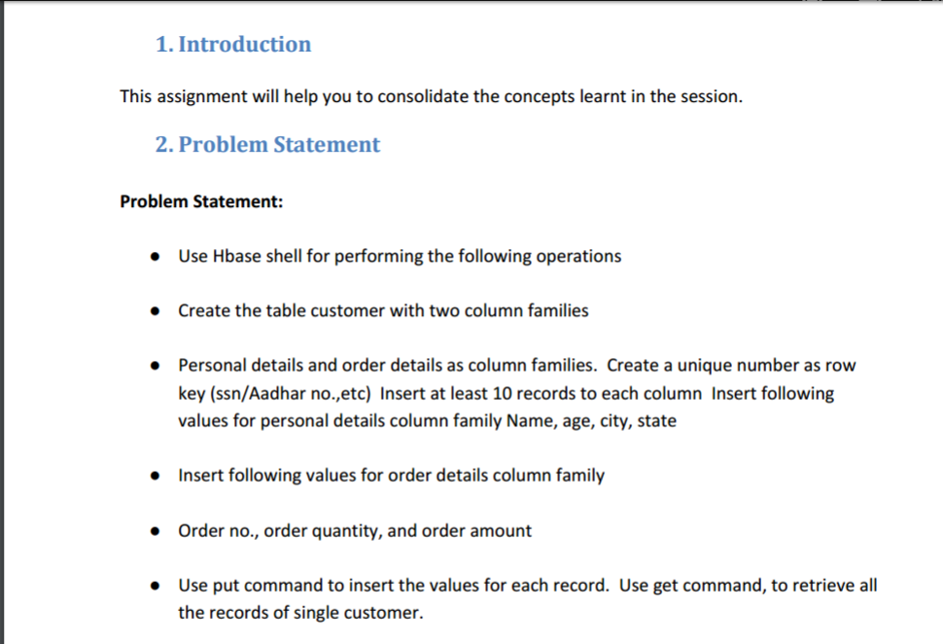

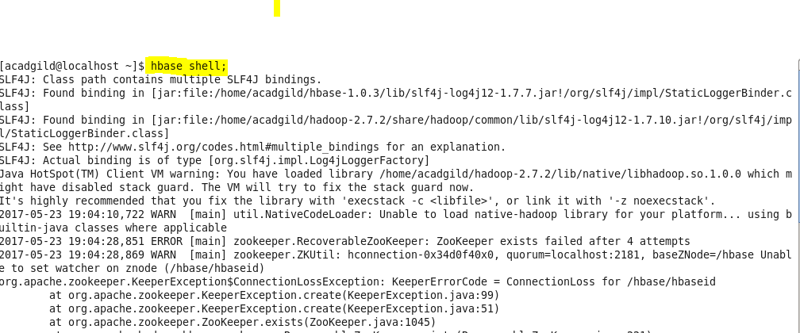

Creating table customer with two column families

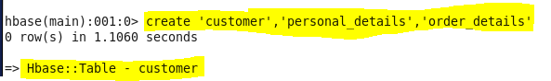

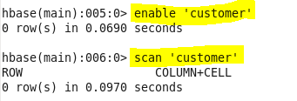

Inserting data into the table customer in personal_details column family:

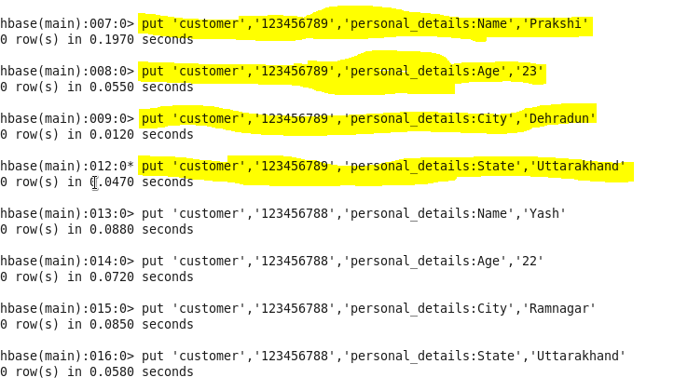

Inserting data into customer table in the order_details column-family

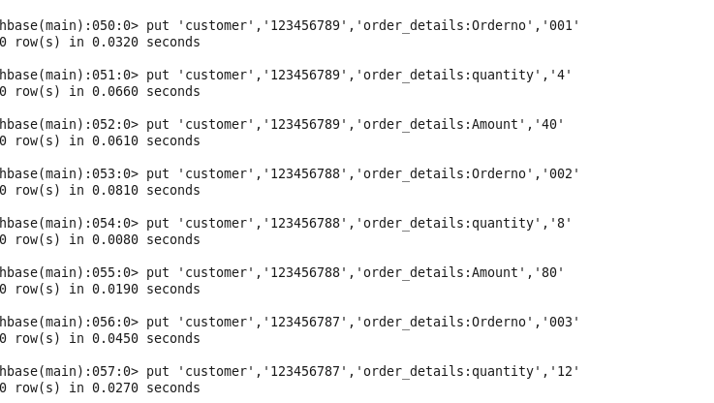

Output can be retrieved using ‘get’ command and the row id (adhaar number) for a single customer:

